# Software Requirements Specification

# for

# Ariane 5 launch accident

Version <1.0>

Prepared by

Group Name: <*place your group name here*>

|  |  |  |
| --- | --- | --- |
| T. Sri Manth | 20VV1A1259 | srimantht.me@gmail.com |
| T. Sai Mukund | 20VV1A1260 | <e-mail> |
| U. Kirtana | 20VV1A1261 | uppalakirtana@gmail.com |
| B. V. S. Yaswanth | 20VV1A1263 | b.v.s.yaswanth@gmail.com |
|  |  |  |

|  |  |
| --- | --- |
| Instructor: | *Dr. B. Tirimula Rao* |
| Course: | Software Engineering Lab |
| Lab Section: | *Information Technology* |
| Teaching Assistant: | *Ms. B. Manasa* |
| Date: | 8/4/22 |

Contents

Software Requirements Specification 1

for 1

Ariane 5 launch accident 1

Contents ii

Revisions iii

1. Introduction 1
   1. Document Purpose 1
   2. Product Scope 1
   3. Intended Audience and Document Overview 1
   4. Definitions, Acronyms and Abbreviations 1
   5. Document Conventions 1
   6. References and Acknowledgments 2
2. Overall Description 3
   1. Product Overview 3
   2. Product Functionality 3
   3. Design and Implementation Constraints 3
   4. Assumptions and Dependencies 3
3. Specific Requirements 4
   1. External Interface Requirements 4
   2. Functional Requirements 7
   3. Use Case Model 7
4. Other Non-functional Requirements 9
   1. Performance Requirements 9
   2. Safety and Security Requirements 9
   3. Software Quality Attributes 10
5. Other Requirements 10

Appendix A – Data Dictionary 11

Appendix B - Group Log 12

Revisions

| Version | Primary Author(s) | Description of Version | Date Completed |
| --- | --- | --- | --- |
| Draft Type and Number | Full Name | Information about the revision. This table does not need to be filled in whenever a document is touched, only when the version is being upgraded. | 00/00/00 |

# Introduction

## Document Purpose

This case study describes the accident that occurred on the initial launch of the Ariane 5 rocket, a launcher developed by the European Space Agency. The rocket exploded shortly after take-off and the subsequent enquiry showed that this was due to a fault in the software in the inertial navigation system.

n June 1996, the then new Ariane 5 rocket was launched on its maiden flight. It carried a payload of scientific satellites. Ariane 5 was commercially very significant for the European Space Agency as it could carry a much heavier payload than the Ariane 4 series of launchers. Thirty seven seconds into the flight, software in the inertial navigation system, whose software was reused from Ariane 4, shut down causing incorrect signals to be sent to the engines.

## Product Scope

This case study illustrates issues with requirements specification, multi-organisational working, critical systems validation and some of the problems of software reuse. The example illustrates that good software engineering practice (reuse, don’t introduce changes unless necessary) can have problems and highlights the need for diversity as well as redundancy. It also shows the organisational complexity of systems development and how organisational issues can lead to systems failure.I have used it in conjunction with lectures on critical systems validation.

## Intended Audience and Document Overview

For the readers the document is intended for, people such as developers, project managers, marketing staff, users, testers, and documentation writers, the “client” and the professor.

## Definitions, Acronyms and Abbreviations

* Ballastic -- moving under the force of gravity only.
* Terminal -- forming or situated at the end or extremity of something.
* Mach -- the ratio of the speed of a body to the speed of sound in the surrounding medium.
* Altitude -- the height of an object or point in relation to sea level or ground level.
* Flight -- the action or process of flying through the air.
* Velocity -- the speed of something in a given direction.
* Thrust -- push suddenly or violently in a specified direction.
* Drag -- pull (someone or something) along forcefully, roughly, or with difficulty.
* Cross Section -- a surface or shape exposed by making a straight cut through something, especially at right angles to an axis.

## Document Conventions

<In general this document follows the IEEE formatting requirements. Use Arial font size 11, or 12 throughout the document for text. Use italics for comments. Document text should be single spaced and maintain the 1” margins found in this template. For Section and Subsection titles please follow the template.

## References and Acknowledgments

* <https://iansommerville.com/software-engineering-book/case-studies/ariane5/>
* <http://www.rvs.uni-bielefeld.de/publications/Reports/ariane.html>
* <http://sunnyday.mit.edu/accidents/Ariane5accidentreport.html>
* <https://www.dropbox.com/s/tr02fmo4xzytzhv/Bashar-Ariane5.pdf?dl=0>
* [www.google.com](http://www.google.com/)

# Overall Description

## Product Overview

The Product is Software Designed to Launch a Rocket . Constitutes Internal Calculations that help in maintaining the rocket in the right parameter of flight.

Scientific, Development and Maintenance Team Interacts with the software.

## Product Functionality

Product provides Calculations like Ballastic Flight, Terminal Velocity, Rocket Altitude, Mach and Speed of Sound.

Each has it’s own importance in launching a rocket.

## Design and Implementation Constraints

* As the product is inherited from the Case Study Of Ariane – 5 Launch Accident, the rocket has blasted in 37 secs into the flight after launch.
* Reason being no proper code reuse.
* The context didn’t provided enough information about how we can develop a complete end to end rocket launching software.
* Also many companies keep their source code confidential, making it much more difficult to get ideas related to it.
* Understanding how various scientific terms are involved and how they can be merged into one so that they can led to a meaningful outcomes is a big task.

## Assumptions and Dependencies

* Any of the modern Operating Systems are Supported.
* Windows, Linux, Mac are basic OS that are fully supported.
* Browser should be of the lastest generation.
* Browsers like Internet Explorer are not supported.
* An active internet connection is highly recommended.
* No further packages or software plugins are required.

# Specific Requirements

## External Interface Requirements

### User Interfaces

**1.HOME PAGE**

For providing navigation buttons to different features in the software

**DESCRIPTION** :

This home page is designed for showing the features of the software designed

The software designed works on calculating various parameters for launching the

Software

**FEATURES:**

1.Ballistic flight calculator

2.terminal velocity calculator

3.rocket altitude calculator

4. mach speed sound calculator

**USER INTERACTION AND RESPONSE:**

Clicking upon any navigation button the user is directed for navigation to the respective page in the software

**2. BALLISTIC FLIGHT CALCULATOR:**

**DESCRPTION:**

This program calculates the maximum height of a launched ballistic shell, or

a shell with drag, and the time from launch when the maximum height is reached.

**FEATURES**

* Initial velocity
* Mass
* Cross section area
* Drag coefficient
* Altitude etc.

**USER INTERACTION AND RESPONSE:**

User will input numerical values and output is shown

Further user can use RAC and home navigation buttons.

**3. TERMINAL VELOCITY CALCULATOR:**

**DESCRIPTION:**

This program calculates the terminal velocity of a falling object.

Circular Orbit Calculator This program calculates the altitude and velocity of an object in a circular orbit about the Earth, Moon or Mars**.**

**FEATURES:**

* Mass
* Cross section area
* Drag coefficient
* Altitude etc.

**USER INTERACTION AND RESPONSE:**

User will input numerical values and output is shown

Further user can use RAC and home navigation buttons.

**4. ROCKET ALTITUDE CALCULATOR:**

**Description:**

This program calculates the terminal velocity of a falling object.

**FEATURES:**

* Angle A
* Angle B
* Angle C
* Angle D etc

**USER INTERACTION AND RESPONSE:**

User will input numerical values and output is shown

Further user can home navigation button.

**5. MACH AND SPEED OF SOUND CALCULATOR:**

**Description:**

This program calculates the speed of sound as a function of temperature and the Mach number as function of object speed and speed of sound.

**FEATURES:**

* Altitude
* Speed etc.

**USER INTERACTION AND RESPONSE:**

User will input numerical values and output is shown

Further user can use RAC and home navigation buttons.

### Hardware Interfaces

* All modern day computers with 32bit or 64bit Architecture supports the software.
* Network Interface Card or a RJ – 45 port are mandatory.
* CPU processor above i3 8th gen, i5 8th gen are recommend.
* Ryzen series of >= 4000 are recommend.
* Standard Keyboard and respective drivers are required.
* Standard Mouse Pointer and respective drivers are required.
* All modern Android Versions are Supported.
* A RAM of atleat 6GB is recommend.
* A ROM of atleast 32GB is recommend.

### Software Interfaces

The list of interfaces implemented in the software are:

1. Home Page.

2. Ballastic Flight Calculator.

3. Terminal Velocity Calculator.

4. Rocket Altitude Calciator.

5. Mach and Speed of Sound Calculator.

## Functional Requirements

*The functionalities provided by the software are primarily:*

* *Taking Precise Inputs form the user.*
* *Showing processed Calculations and Output to the User.*
* *Providing navigation to other interfaces wherever required.*

### F1: The system shall take precise Inputs form the user.

**3.2.2 F2: The system shows processed Calculations and Output to the User.**

**3.2.3 F3: The system shows provide navigation to other interfaces wherever required.**

## Use Case Model

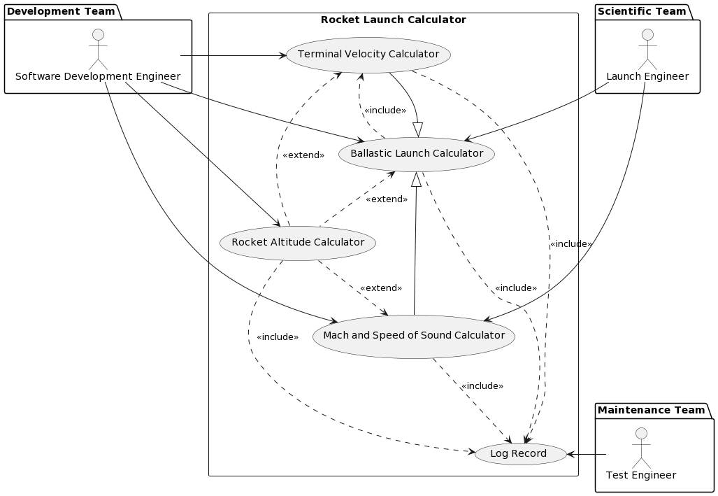

### Use Case #1

TO DO: Provide a specification for each use case diagram

**Author – 20VV2A12-(59,60,61,63).**

**Purpose** – The use case is designed to provide the nescessary calculators that help in further computations of Launching the Rocket.

**Requirements Traceability – User Input tracking, Displaying Outputs, Navigation, Log Data Base.**

**Priority** – High Priority.

**Preconditions** –

* The Hardware Components must be in good working state.
* The Calculators must take in accurate input and return accurate output.

**Post conditions** -

* All performed operations and their results must be stored in the log report
* Repeated Testing must be conducted to Identify Errors.

**Actors** – Launch Engineer, Test Engineer, Software Development Engineer.

**Extends – Extends No other Use Case.**

**Flow of Events**

* + Basic Flow -
  + Rocket Launch Calculator is Initiated.
  + Provides Navigation Buttons for the User on the Home Page.
  + User Selects the Feature and gets navigated to the respective Interface.
  + User Inputs data into the selected Interface.
  + Alternative Flow :

- Any response that too far from the normal values may be due to in-accurate data being given as input.

- In case of no output, transaction is recorded in the log data base and stored for further investigation and user is shown message to re enter proper values.

* + Exceptions :

- Exceptional Events Proved proper instructions to user for a appreciable results from the calculators.

**Includes** (other use case IDs)

**Notes/Issues** - Any relevant notes or issues that need to be resolved

### Use Case #2

…

# Other Non-functional Requirements

## Performance Requirements

<If there are performance requirements for the product under various circumstances, state them here and explain their rationale, to help the developers understand the intent and make suitable design choices. Specify the timing relationships for real time systems. Make such requirements as specific as possible. You may need to state performance requirements for individual functional requirements or features.

TODO: Provide performance requirements based on the information you collected from the client/professor. For example, you can say “P1. The secondary heater will be engaged if the desired temperature is not reached within 10 seconds”>

## Safety and Security Requirements

<Specify those requirements that are concerned with possible loss, damage, or harm that could result from the use of the product. Define any safeguards or actions that must be taken, as well as actions that must be prevented. Refer to any external policies or regulations that state safety issues that affect the product’s design or use. Define any safety certifications that must be satisfied. Specify any requirements regarding security or privacy issues surrounding use of the product or protection of the data used or created by the product. Define any user identity authentication requirements.

TODO:

* Provide safety/security requirements based on your interview with the client - again you may need to be somewhat creative here. At the least, you should have some security for the mobile connection.

## Software Quality Attributes

<Specify any additional quality characteristics for the product that will be important to either the customers or the developers. Some to consider are: adaptability, availability, correctness, flexibility, interoperability, maintainability, portability, reliability, reusability, robustness, testability, and usability. Write these to be specific, quantitative, and verifiable when possible. At the least, clarify the relative preferences for various attributes, such as ease of use over ease of learning.

TODO: Use subsections (e.g., 4.3.1 Reliability, 4.3.2 Adaptability, etc…) provide requirements related to the different software quality attributes. Base the information you include in these subsections on the material you have learned in the class. Make sure, that you do not just write “This software shall be maintainable…” Indicate how you plan to achieve it, & etc…Do not forget to include such attributes as the design for change (e.g. adapting for different sensors and heating/AC units, etc.). Please note that you need to include **at least** 2 quality attributes. You can Google for examples that may pertain to your system.>

# Other Requirements

<This section is **Optional.** Define any other requirements not covered elsewhere in the SRS. This might include database requirements, internationalization requirements, legal requirements, reuse objectives for the project, and so on. Add any new sections that are pertinent to the project.>

Appendix A – Data Dictionary

*<Data dictionary is used to track all the different variables, states and functional requirements that you described in your document. Make sure to include the complete list of all constants, state variables (and their possible states), inputs and outputs in a table. In the table, include the description of these items as well as all related operations and requirements.>*

Appendix B - Group Log

<Please include here all the minutes from your group meetings, your group activities, and any other relevant information that will assist in determining the effort put forth to produce this document>